Monthly Construction Report

October 2024

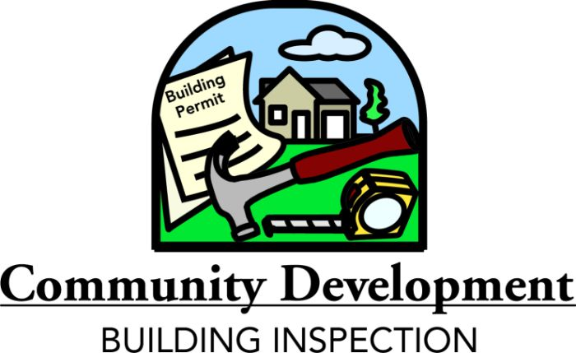

This report is sent digitally to conserve our natural resources.

CONSTRUCTION ACTIVITY SUMMARY
October 2024

TOTAL PERMIT ACTIVITY
 | Number of Permits | Valuation
New Residential, Commercial, Addition & Remodel, Footing and Foundations and Miscellaneous | 506 | $12,227,173

RESIDENTIAL
 | No. of Permits/Buildings | Number of Units | Valuation
Single Family Dwellings | 8 | 8 | $2,798,021
Multi-Family (Buildings) | 6/2 | 6 | $1,859,701
Remodel and Addition Work | 37 | N/A | $907,968

COMMERCIAL
 | Number of Permits | Valuation
New Commercial Projects | 0 | $0

Commercial projects valued over $100,000 are summarized.

 | Building Inspection Division  Construction Activity Comparative Analysis

 |  | Oct  2024 | Oct  2023 | YTD  2024 | YTD  2023
New Single Family Dwelling Units* | # of Permits  # of Units  Valuation | 8  8  2,798,021 | 6  6  2,856,774 | 69  69  31,130,734 | 91  91  37,007,671
Single Family Footing & Foundation Only | # of Permits  Valuation | 0 | 0 | 11  720,918 | 1  50,000
New Multi-Family  Dwellings Units* | # of Permits  # of Buildings  # of Units  Valuation | 6  2  6  1,859,701 | 6  1  6  1,680,119 | 84  26  141  41,816,907 | 54  26  521  85,043,047
Multi-Family Footing & Foundation Only | # of Permits  Valuation | 0 | 0 | 0 | 7  2,442,307
Residential Additions and Remodels | # of Permits  Valuation | 37  907,968 | 26  738,444 | 305  8,686,440 | 242  7,599,944
New Commercial Projects | # of Permits  Valuation | 0 | 1  426,528 | 18  56,721,702 | 31  68,157,137
Commercial Footing & Foundation Only | # of Permits  Valuation | 0 | 0 | 2  30,000 | 0
Commercial Additions and Remodels | # of Permits  Valuation | 10  518,075 | 13  987,559 | 97  36,040,578 | 117  65,901,533
Miscellaneous Permits | # of Permits  Valuation | 445  6,143,408 | 216  2,712,122 | 3,481  44,658,189 | 1,990  28,973,246
Mobile Home Permits | # of Permits  Valuation | 0 | 43  205,287 | 28  128,600 | 50  1,000,175
TOTALS | # of Permits  Valuation | 506  12,227,173 | 311  9,606,833 | 4,095  219,934,068 | 2,583  296,175,060

*Number of units and number of permits will differ due to some multiple unit dwellings being issued under one permit.

